VALUATION REPORT OF

VAISHALI LOKESH PATIL & LOKESH SAMPAT PATIL
(PROPOSED PURCHASER)

At
Flat No. 2402, 24th Floor, B-Wing, Shraddha Park City, LIG Mahindra & Mahindra CHSL, Shree Krishna Nagar, Survey No. 218, Hissa No. 1(P), 213 Hissa No. 2(P), 213 Hissa No. 3(P), CTS No. 2157/A, 2158/A, 2292/A/1 of Village Dahisar, Borivali East, Mumbai - 400066.

CANARA BANK-VASAI BRANCH
VALUATION REPORT (IN RESPECT OF FLAT)

Ref - UCVLLP/CANARA/25-26/520 Date: 12/09/2025

I | GENERAL
1. | Purpose for which the valuation is made | :
2. | a) Date of Inspection | :
 | b) Date on which the valuation is made | :
3. | Name of the owner (s) and his/ their address(es) with Phone No. (Details of share of each owner in case of joint ownership). | :
4. | List of documents produced for perusal | :
5. | Brief Description of the property | : | Address:  Landmark:  Building Details:  Property Details:  Amenities: Landholding Type:
6 | Location of the property
 | a) Plot No./ Survey No. | :
 | b) Door No./ Property No. | :
 | c) T. S. No/Village | :
 | d) Ward/ Taluka | :
 | e) Mandal/District | :
7. | Postal address of the property | :
8. | City/ Town | :
 | Residential Area | :
 | Commercial Area | :
 | Industrial Area | :
9. | Classification of Area | :
 | i) High/ Middle/ Poor | :
 | ii) Urban/ Semi-Urban/ Rural | :
10 | Coming under Corporation limit/ Village Panchayat/Municipality. | :
11 | Whether covered under any State/ Central Govt. enactments (e.g., Urban Land Ceiling Act) or notified under agency area/ scheduled area/cantonment area. | :
12. | Boundaries of the property | : | As per Actual | As per Flat
 | North | :
 | South | :
 | East | :
 | West | :
13 | Dimensions of the site | : | As per Documents
 | North
 | South
 | East
 | West
14 | Extent of the site | : | As per agreement | Actual  (As per measurement)
14.1 | Latitude, Longitude & Co-ordinates of flat | :
15. | Extent of the site considered for Valuation | :
16. | Whether occupied by the owner/ tenant? If occupied by tenant since how long? Rent received per month. | :
11 | APARTMENT BUILDING
1. | Nature of the Apartment | :
2. | Flat No. & Floor | :
3. | Name of the Apartment | :
4. | Postal Address | :
5. | Location | :
 | T. S. No. | :
 | Block No. | :
 | Ward No. | :
 | Village/Municipality/Corporation | :
 | Door No. Street or Road (Pin Code) | :
6. | Description of the Locality Residential/ Commercial/Mixed. | :
7. | Year of Construction | :
8. | Number of floors | :
9. | Type of structure | :
10 | Number of Dwelling Units in the Building. | :
11 | Quality of Construction | :
12 | Appearance of the Building | :
13 | Maintenance of the Building | :
14 | Facilities available. | :
 | Lift | :
 | Protected Water Supply | :
 | Under2nd Sewerage | :
 | Car Parking—Open/ Covered | :
 | Is Compound wall existing? | :
 | Is pavement laid around the Building? | :
III. | FLAT
1. | The floor in which the property is situated | :
2. | Door No. of the property | :
3. | Specifications of the property | :
 | Roof | :
 | Flooring | :
 | Doors | :
 | Windows | :
 | Fittings | :
 | Finishing | :
4. | House Tax | :
 | Assessment No. | :
 | Tax paid in the name of | :
 | Tax amount | :
5. | Electricity Service Connection No. | :
 | Meter Card is in the name of | :
6. | How is the maintenance of the property? | :
7. | Deed executed in the name of | :
8. | What is the undivided area of land as per Sale Deed? | :
9. | What is the plinth area of the property? | :
10 | What is the Floor Space Index (Approx.). | :
11 | What is the Carpet area of the property? | :
12 | Is it Posh/ I Class/ Medium/ Ordinary? | :
13 | Is it being used for Residential/ Commercial/Industrial purpose? | :
14 | Is it owner occupied or let out? | :

PART C - VALUATION OF EXISTING PROPERTY

IV | MARKETABILITY
1. | How is the marketability? | :
2. | What are the factors favouring for an extra Potential Value? | :
3. | Any negative factors are observed which affect the market value in general? | :
V | RATE
1. | After Analysing the comparable sale instances, what is the composite rate for a similar property with same specifications in the adjoining locality? | :
2. | Assuming it is a new construction, what is the adopted basic composite rate of the property under valuation after comparing with the specifications and other factors with the property under comparison (given details). | :
3. | Break-up for the Rate:
 | i) Building + Services | :
 | ii) Land + Others | :
4. | Guideline rate obtained from the Registrar’s Office (evidence thereof to be enclosed). | :
VI. | COMPOSITE RATE ADOPTED:
a. | Depreciated Building Rate
 | Replacement cost of property with Services[v(3)i] | :
 | Age of building | :
 | Life of the Building estimated | :
 | Depreciation percentage assuming the salvage value as | :
 | Depreciated Ratio of the Building | :
b. | Total Composite Rate arrived for valuation. | :
 | Depreciated Building Rate VI(a) | :
 | Rate of Land and Other V(3)ii | :
 | Total Composite Rate | :

DETAILS OF VALUATION

S.  No. | Description | Carpet area  (Sq.ft.) | Rate/sq.ft.  (Rs.) | Value  (Rs.)
1. | Present value of the property | 566 | 27,000/- | Rs. 1,52,82,000/-
2. | Car parking space | -- | --- | --
3. | Wardrobes | -- | -- | --
4. | Showcases/ admirals | -- | -- | --
5. | Kitchen arrangements | -- | -- | --
6. | Superfine finish | -- | -- | --
7. | Interior Decorations, Furniture & Fixture | --- | --
8. | Electricity deposits/Electrical fittings etc. | -- | -- | --
9. | Extra collapsible gates/ grill works etc. | -- | -- | --
10. | Potential Value, if any. | -- | -- | --
11. | Others | -- | -- | --
 | TOTAL VALUE (After 100% Work Completion) |  |  | Rs. 1,52,82,000/-
 | Say Value (After 100% Work Completion) |  |  | Rs. 1,52,80,000/-
 | As per current stage of 15% work completion the value of property is: |  |  | Rs. 22,92,000/-
(Rs. One Crore Fifty-Two Lakhs Eighty Thousand Only)

(Valuation: Here, the approved valuer should discuss in details his approach to valuation of property and indicate how the value has been arrived at, supported by necessary calculation. Also, such aspects as impending threat of acquisition by government for road widening/public service purposes, sub merging & applicability of CRZ provisions (Distance from sea-coast/tidal level must be incorporated) and their effect on i) salability ii) likely rental value in future and iii) any likely income it may generate may be discussed)

As a result of my appraisal and analysis, it is my considered opinion that the present fair market value of the above property in the prevailing condition with aforesaid specifications is Rs. 1,52,80,000/- (Rs. One Crore Fifty-Two Lakhs Eighty Thousand Only). (After 100% Work Completion)

The Book Value of the above property is Rs. 1,10,37,000/- (as per draft agreement)

The Realizable Value (90%) of the flat is Rs. 1,37,52,000/- (Rs. One Crore Thirty-Seven Lakh Fifty-Two Thousand Only) (After 100% Work Completion)

The Distress Value (80%) of the flat is Rs. 1,22,24,000/- (Rs. One Crore Twenty-Two Lakh Twenty-Four Thousand only) (After 100% Work Completion)

The Insurance Value of the flat is Rs. 24,92,000/- (Rs. Twenty-Four Lakh Ninety-Two Thousand Only)

The Government value of the flat is Rs. 82,17,370/- (Rs. Eighty-Two Lakh Seventeen Thousand Three Hundred Seventy Only)

Estimated Rental Value of the flat is Rs. 32,000/- (Rs. Thirty-Two Thousand Only).

Place: Thane Manoj Kumar Sharma
Date: 12/09/2025

Govt. Valuer & Chartered Engineer
Panel Valuer of Canara Bank
(IBBI/RV/07/2019/11044)

The undersigned has inspected the property detailed in the Valuation Report dated 12/09/2025. We are satisfied that the fair and reasonable market value of the property is Rs. 1,52,80,000/- (Rs. One Crore Fifty-Two Lakhs Eighty Thousand Only) (After 100% Work Completion)

Signature
(Name of the Branch Manager with Office Seal)
Disclaimer, Notes and Limitation:
- We have finalized the report on the basis of site visit and copy of: Draft Sale Agreement, C.C., RERA Certificate, Approved Plan. However, we have not been provided with latest registered Sale Agreement/Index II, Property Card, Title report, etc. for verification purpose.
- The said Property is in Under Construction Stage at the time of visit.
- Currently plinth work is completed and remaining work is under progress.
- At present only 15% of the building is completed, hence the current value is given as per the work completion at site.
- Project name was displayed at site
- Property is situated in residential cum commercial area.
- As there is range Rs. 26,000/- to Rs. 28,000/- per sq.ft. on Carpet area. We are further discounting rate by 10% to 20% than current market rate hence we have adopted Rate of Rs. 27,000/-per sq.ft. on Carpet area.
- We consider the area given in the Draft Agreement, declared by the party and submitted for registration with the government authorities as final for valuation purpose. Any area that is not stated in the Draft Agreement is not considered for valuation unless the area is measured by us in which case that may be considered for valuation purpose.
- The scope of our valuation work is only for banks financial/loan purpose. Further, please be noted that this report shall not be used for any litigation purpose.
- Encumbrance of Loan, Government and other dues, stamp duty, registration charges, transfer charges etc, if any are not considered in the valuation. We assumed that the assets are free from encumbrance unless otherwise stated to us by the party in writing.
- The value given in our report is the estimate of the Fair Market value of the property as on date, considering various aspects of the property as mentioned above.
- The value given in our report is the estimate of the Fair Market value of the property as on date, considering various aspects of the property like amenities in projects, locational advantages, demand and supply equation, interior designing done in the property, outside view, Vashtu aspects etc. which is generally more than the Government ready reckoner value.

PART D – CERTIFICATE
- It is hereby certified that in my opinion
The present stage value of the property which is fully completed is Rs. 22,92,000/-.
- The present market value of the property by adopting suitable composite rate is Rs. 1,52,80,000/- (Rs. One Crore Fifty-Two Lakhs Eighty Thousand Only).
- The forced sale value of the property is estimated as 20% less than the present market value
- The Realizable value of the property is estimated as 10% less than the present market value
- Number of title deed(s) involved in this property is ---. The relevant document for the subject flat in the opinion of this valuer is the deed dated with Registration Number ----- registered in the ---- Registrar’s Office ----
- If this property is offered as security, the concerned financial institution is requested to verify the extent of undivided share of land mentioned this valuation report with respect to the latest legal opinion.
- Value varies with the purpose and date of valuation. This report is not to be referred if the purpose is different other than mentioned in I (1).
- The property was inspected on 12/09/2025 by our representative, Mr. Krishna in the presence of Sneha (Sales-9833733044)
- The legal aspects were not considered in this valuation.
- This valuation work is undertaken by the valuer based upon the request from bank.

Place: Thane
Dated: 12/09/2025
Manoj Kumar Sharma

Govt. Valuer & Chartered Engineer
Panel Valuer of Canara Bank
(IBBI/RV/07/2019/11044)

PHOTOGRAPHS OF PROPERTY

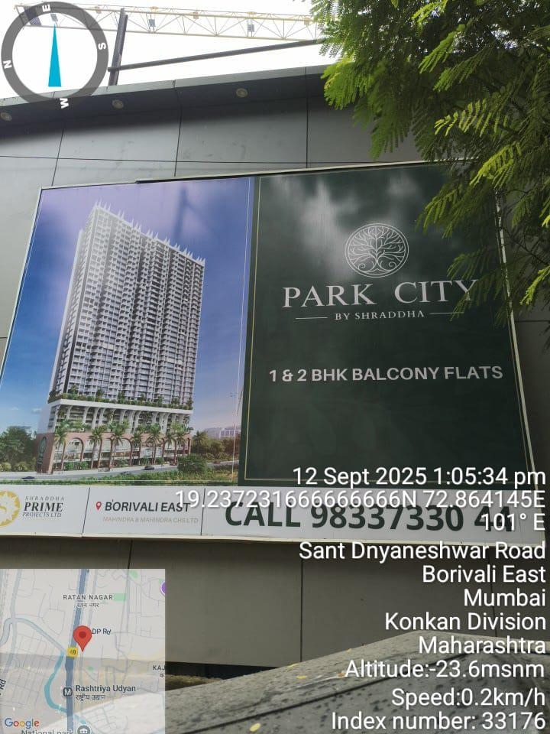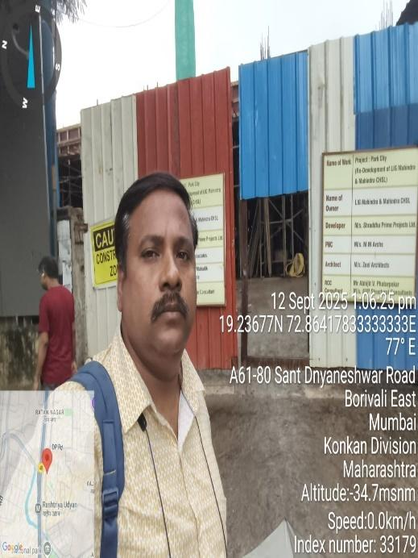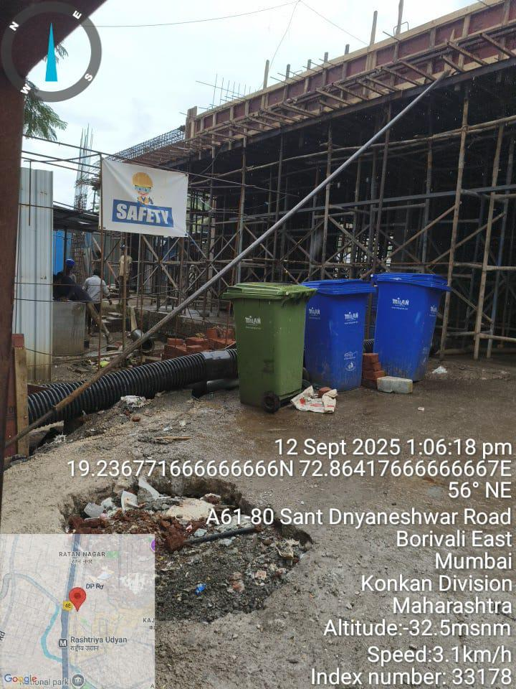

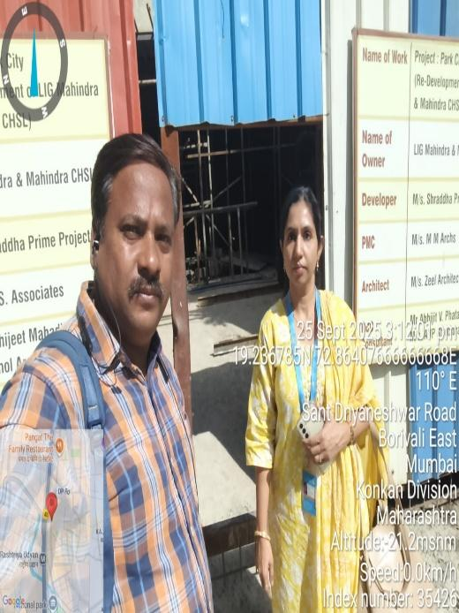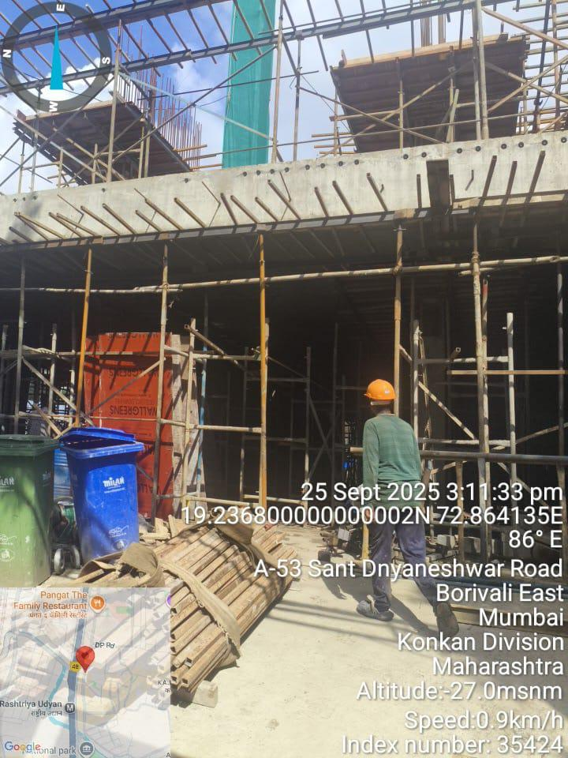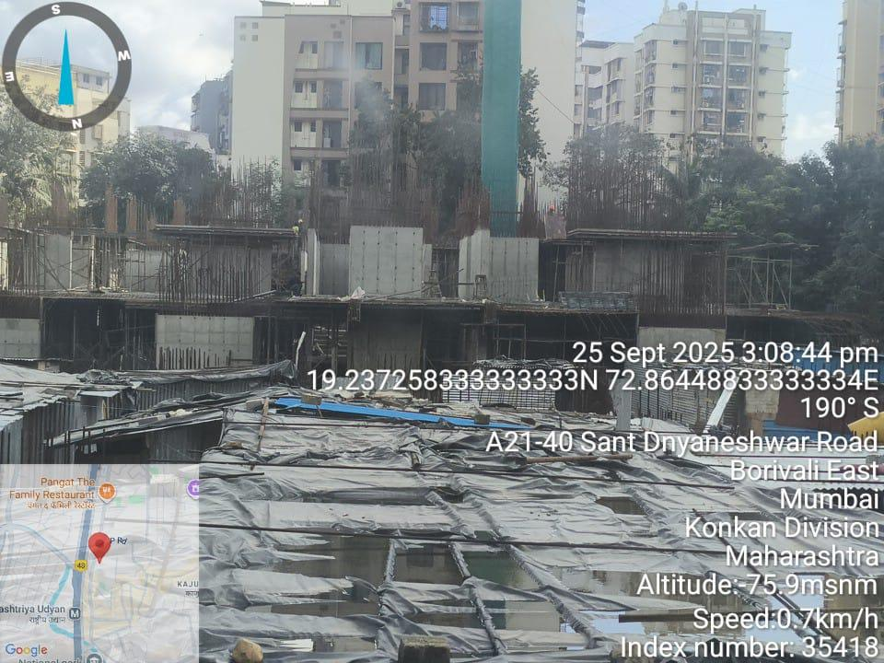

Location Map
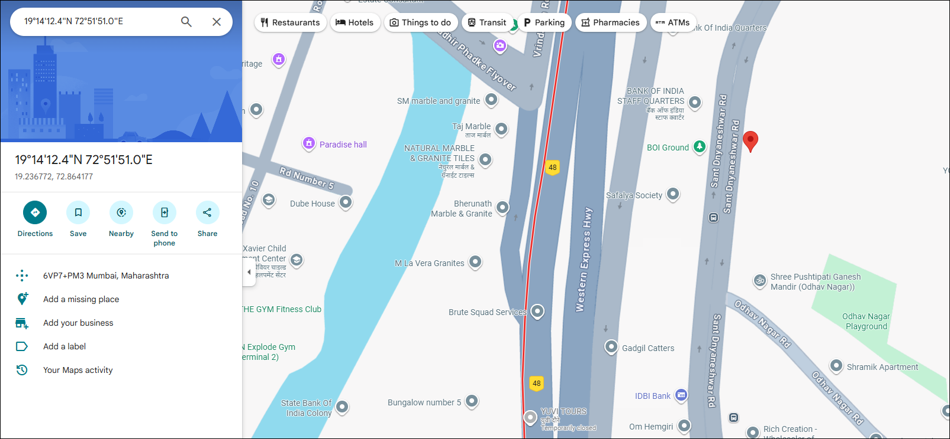

Government Ready Reckoner rate 2025-2026
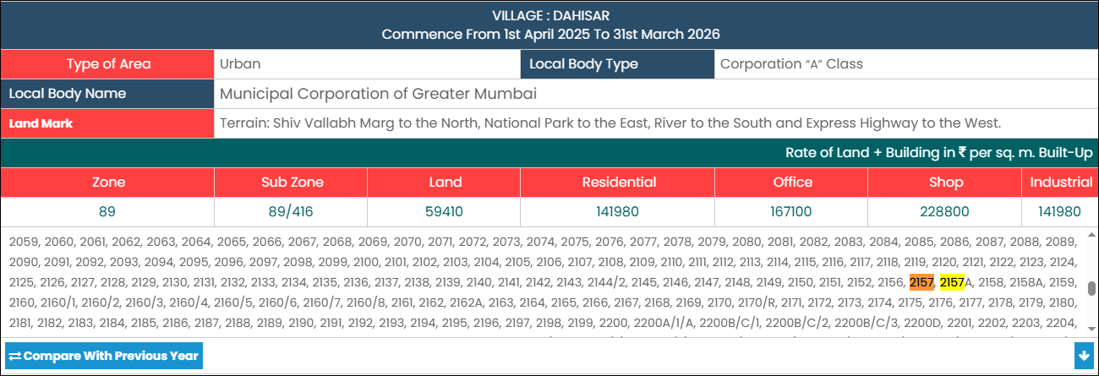

Comparable
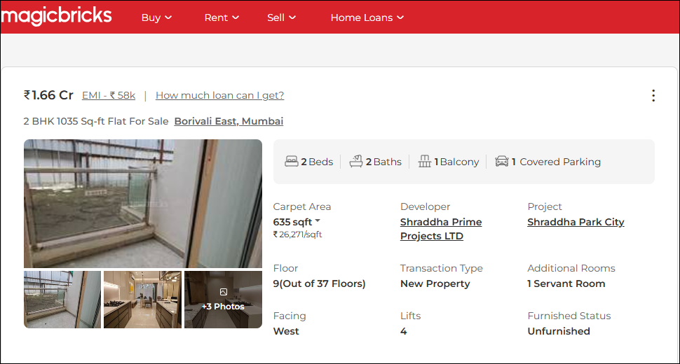

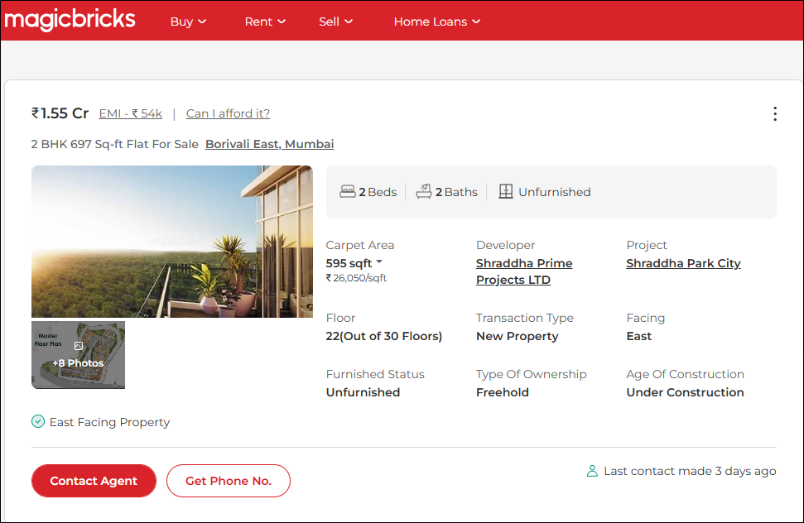

Property Documents
